**ITA0448 – STATISTICS WITH R PROGRAMMING FOR VECTORIZED EXPRESSIONS**

**SUBMITTED BY: DEVADARSHINI J REG NO: 192124092**

**DATE: 21/03/2023**

1. **Write an R program to take input from the user (name and age) and display the values. Also print the version of R installation.**

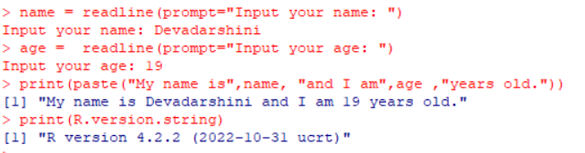

1. **Write an R program to get the details of the objects in memory.**

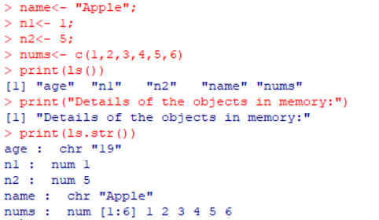

1. **Write a R program to create a sequence of numbers from 20 to 50 and find the mean of numbers from 20 to 60 and sum of numbers from 51 to 91.**

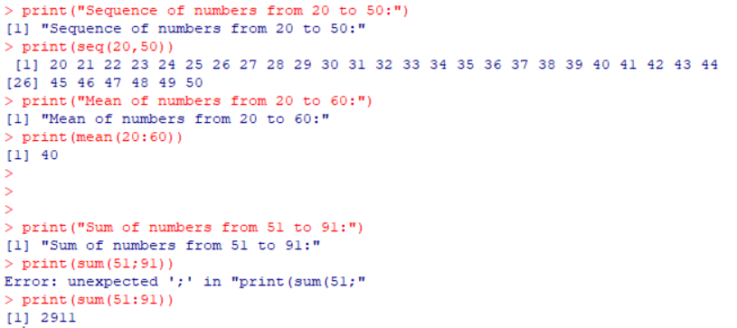

1. **Write a R program to create a vector which contains 10 random integer values between -50 and +50.**

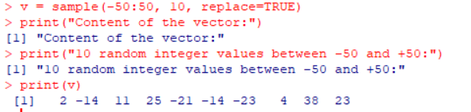

1. **Write a R program to get all prime numbers up to a given number (based on the sieve of Eratosthenes).**

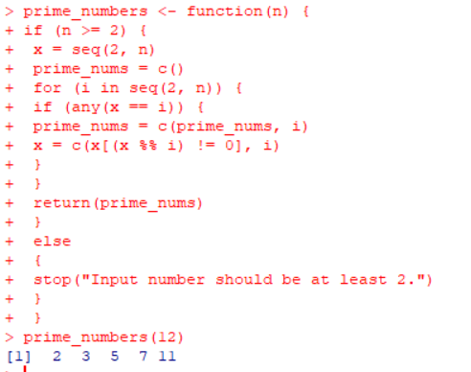

1. **Write a R program to extract first 10 english letter in lower case and last 10 letters in upper case and extract letters between 22 nd  to 24 th  letters in upper case.**

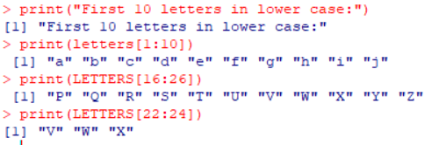

1. **Write a R program to find the maximum and the minimum value of a given vector.**

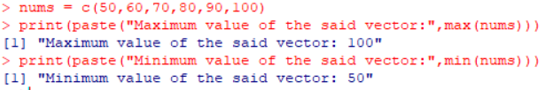

1. **Write a R program to get the unique elements of a given string and unique numbers of vector.**

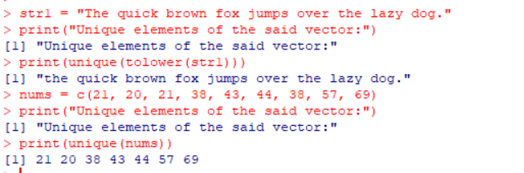

1. **Write a R program to create three vectors a,b,c with 3 integers. Combine the three vectors to become a 3×3 matrix where each column represents a vector. Print the content of the matrix.**

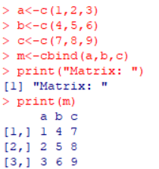

1. **Write a R program to create a list of random numbers in normal distribution and count occurrences of each value.**

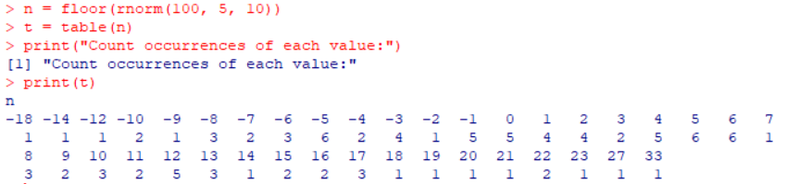

1. **Write a R program to create three vectors numeric data, character data and logical data. Display the content of the vectors and their type.**

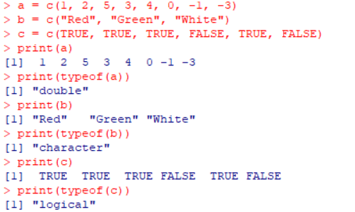

1. **Write a R program to create a 5 x 4 matrix , 3 x 3 matrix with labels and fill the matrix by rows and 2 × 2 matrix with labels and fill the matrix by columns.**

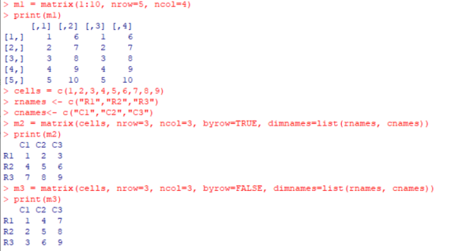

1. **Write a R program to create an array, passing in a vector of values and a vector of dimensions. Also provide names for each dimension.**

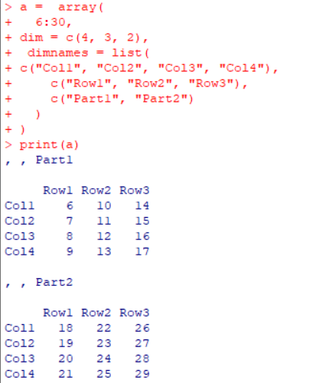

1. **Write a R program to create an array with three columns, three rows, and two “tables”, taking two  vectors as input to the array.  Print the array.**

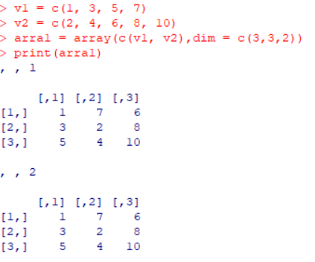

1. **Write a R program to create a list of elements using vectors, matrices and a functions. Print the content of the list.**

